Use Case Diagram:
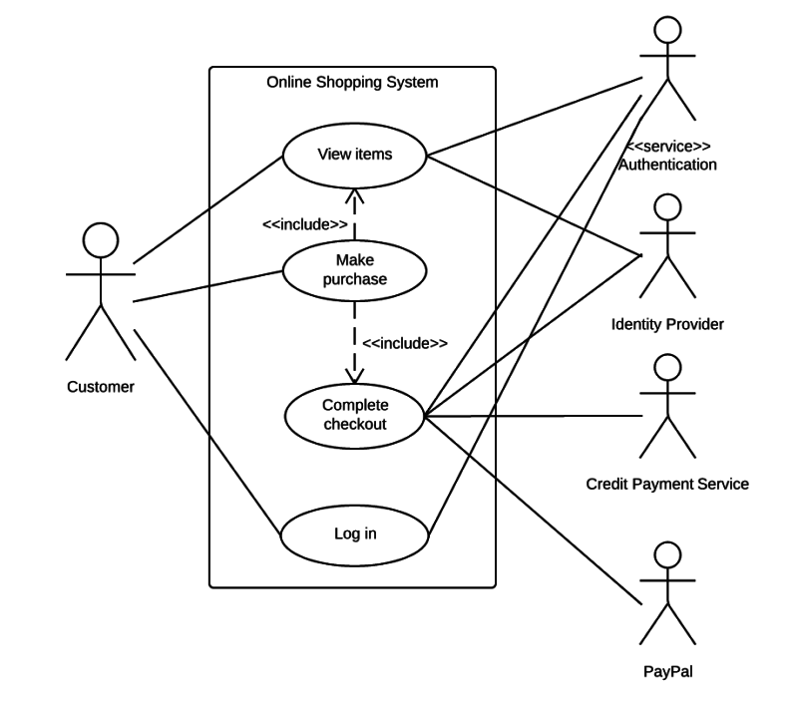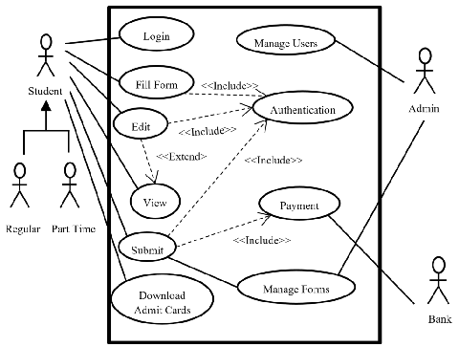
Class Diagram:
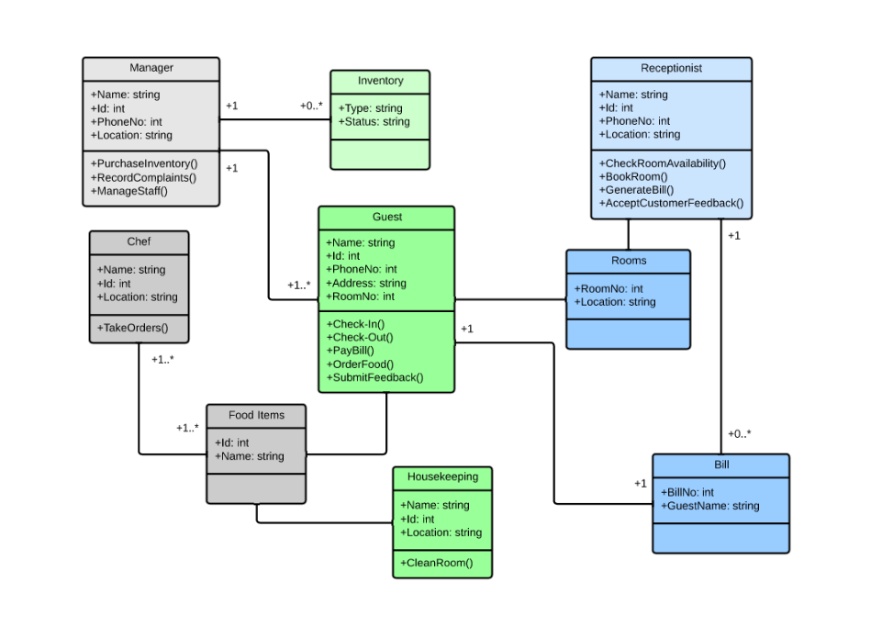

Sequence Diagram:
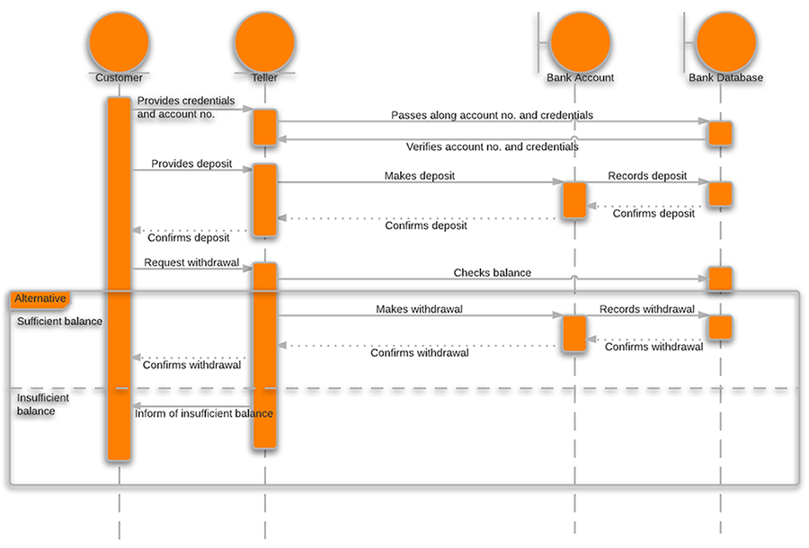

State Chart Diagram:
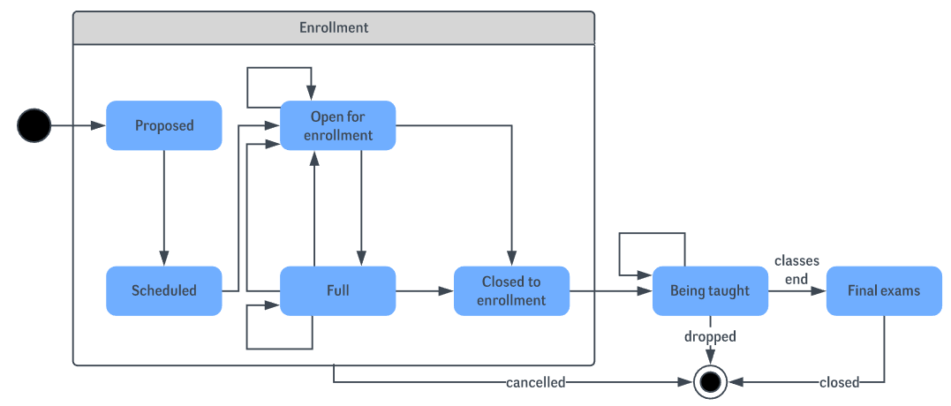

Activity Diagram:
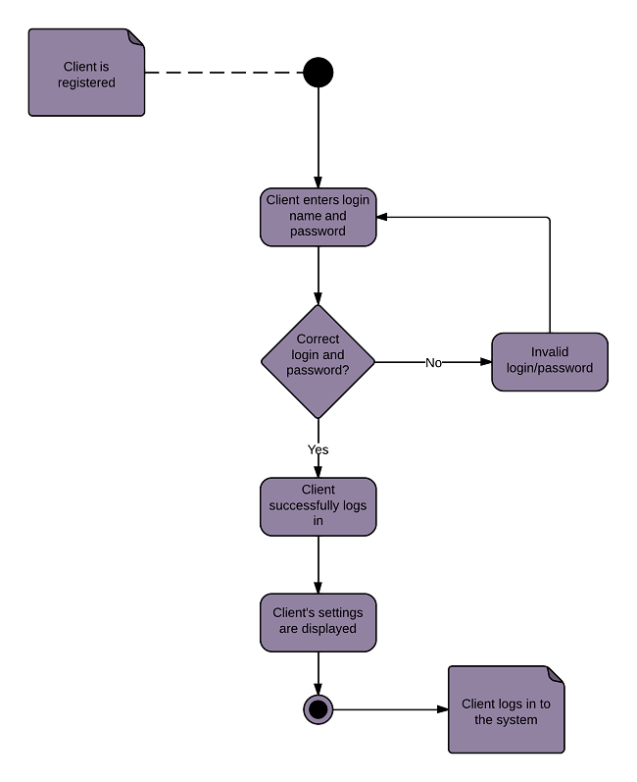
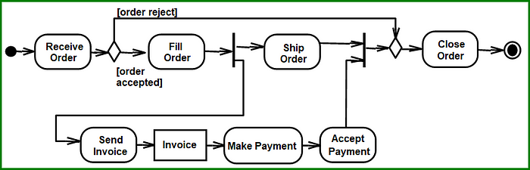
https://medium.com/@joshuaudayagiri/uml-activity-diagram-36aea144793b
Look AT This for knowing what NODES to USE ^^^^^^^^^

